Deployment of Hopitality-App on Kubernetes & AWS

  - Course Name: DevOps

Institution Name: Medicaps University – Datagami Skill Based Course

Student Name(s) & Enrolment Number(s):
Sr no | Student Name | Enrolment Number
1 | HARSH RAI | EN22CS301393
2 | HEMANT DHAKAD | EN22CS301421
3 | GAURAV DWIVEDI | EN23CS3L1008
4 | GOUTAM VERMA | EN22CS301375
5 | HARSHWARDHAN YADAV | EN22CS301416

Group Name: : Group 12D4
Project Number: : AAI-08
Industry Mentor Name: Datagami
University Mentor Name: Avnesh Joshi
Academic Year: 2025 – 2026

Problem Statement & Objectives

Problem Statement

Project Objectives

Scope of the Project

Proposed Solution
- Key features (Just mention key features here no need to go into details)
- Overall Architecture / Workflow
- Tools & Technologies Used (If applicable)

Results & Output
Add the below details here:
- Screenshots / outputs
- Reports / dashboards / models
- Key outcomes

Conclusion
Mention a brief conclusion about your project summing up everything you have worked on and the key learning.

Future Scope & Enhancements

Problem Statement & Objectives
1. Problem Statement
Modern software deployment processes are often manual, time-consuming, and prone to errors. Developers frequently face issues such as inconsistent environments, downtime during updates, and lack of automation in build and deployment workflows.
Traditional deployment approaches do not ensure scalability, reliability, or continuous delivery. There is a need for an automated system that can handle application packaging, deployment, and updates efficiently while maintaining high availability and minimizing downtime.

2. Project Objectives
The primary objectives of the Hospitality Application DevOps Pipeline are as follows:
• Develop a containerized web application
Design and implement a lightweight Python Flask application that can be packaged into a Docker container for consistent execution across environments.
• Implement a CI/CD pipeline
Build an automated pipeline using Jenkins to handle continuous integration and continuous deployment, reducing manual intervention in the software delivery process.
• Enable containerization using Docker
Package the application along with its dependencies into Docker images to ensure portability, consistency, and ease of deployment.
• Deploy application using Kubernetes
Utilize Kubernetes for container orchestration, enabling automated deployment, scaling, and management of application instances.
• Achieve zero-downtime deployment
Implement Kubernetes rolling update strategy to ensure application updates occur without service interruption, maintaining high availability.
• Automate build and deployment workflow
Integrate GitHub, Jenkins, Docker, and Kubernetes to create a seamless pipeline from code commit to deployment.

• Ensure scalability and high availability
Design the system to support multiple replicas and load distribution, ensuring reliability under varying workloads.
• Build a modular and extensible architecture
Develop a system where components such as CI/CD tools, container registry, or cloud infrastructure can be replaced or extended without major redesign.

3. Scope of the Project
The Hospitality Application DevOps Pipeline is designed to provide a complete and automated solution for application deployment using modern DevOps practices.
The scope of the project includes the following key aspects:

• End-to-End Deployment Automation
The system covers the entire application deployment lifecycle, including code integration, containerization, image storage, and deployment to a Kubernetes cluster. It eliminates manual deployment steps by automating the complete workflow through a CI/CD pipeline.

• Containerized Application Deployment
The application is packaged using Docker, ensuring consistent execution across development, testing, and production environments. This removes dependency-related issues and improves portability.

• CI/CD Pipeline Integration
The project integrates GitHub and Jenkins to enable continuous integration and continuous deployment. Code changes automatically trigger the pipeline, ensuring rapid and reliable delivery of updates.
• Kubernetes-Based Orchestration
The system uses Kubernetes to manage application deployment, scaling, and lifecycle. It ensures high availability, load balancing, and efficient resource utilization through container orchestration.

• Zero-Downtime Deployment Strategy
The project implements Kubernetes rolling updates to ensure that application updates are deployed without service interruption, maintaining continuous availability for end users.

• Scalability and High Availability
The system supports multiple replicas of the application, allowing it to handle increased load and ensuring reliability even in case of failures.

• Cloud Deployment Capability
The architecture supports deployment on local environments (Minikube) as well as cloud platforms such as AWS, enabling flexibility and real-world applicability.

• Modular and Extensible Architecture
The system is designed with modular components, allowing easy integration of additional features such as monitoring, logging, auto-scaling, and advanced CI/CD tools without major redesign.

• Web-Based Accessibility
The deployed application is accessible through a web browser using a Kubernetes service, allowing users to interact with the application easily without requiring technical setup.

Proposed Solution
Key Features
• CI/CD Pipeline Automation (Jenkins)
Automated build and deployment process triggered on code changes using Jenkins pipeline.

• Containerization using Docker
Application is packaged into Docker containers ensuring consistency across environments.
• Kubernetes-Based Deployment
Application is deployed and managed using Kubernetes with support for scaling and orchestration.
• Zero-Downtime Rolling Updates
Kubernetes rolling update strategy ensures seamless application updates without service interruption.
• Docker Hub Integration
Centralized storage and version management of Docker images for deployment.
• Scalable Architecture using Replicas
Multiple pod replicas ensure high availability and load distribution.
• Automated Deployment Workflow
End-to-end automation from code commit to production deployment.
• Web-Based Application Access
Application is accessible through a browser via Kubernetes NodePort service.
• Cloud Deployment Support (AWS Ready)
System can be deployed on cloud infrastructure such as AWS EC2 for real-world usage.

2. Overall Architecture / Workflow
1. Overall Architecture

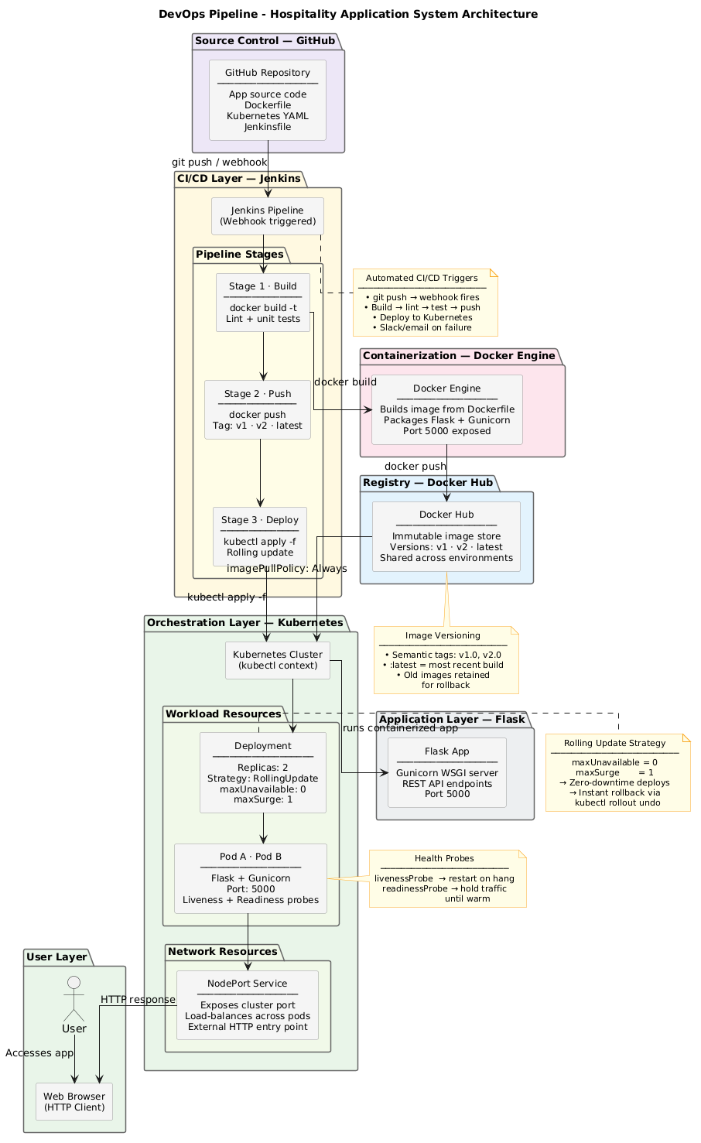

2. Process Flow
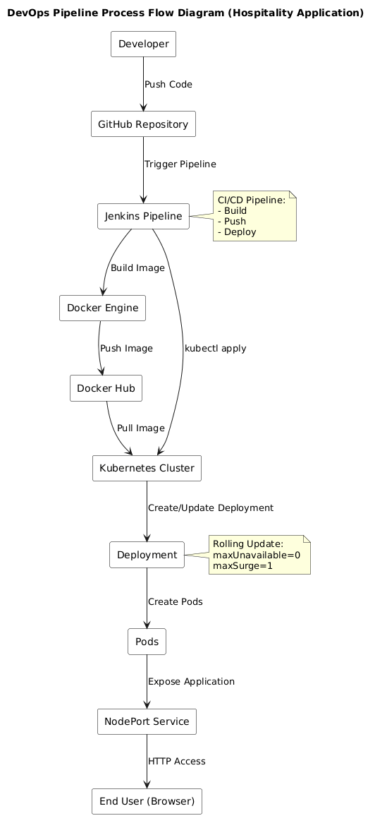

The system follows a modular, layered DevOps architecture with an automated CI/CD workflow:
- Developer pushes application code to the GitHub repository
- GitHub triggers the Jenkins pipeline using a webhook event
- Jenkins orchestrates the CI/CD workflow
- Jenkins builds the application using Docker by:
o Creating a Docker image from the source code
o Tagging the image with a version (v1, v2, etc.)
- The Docker image is pushed to Docker Hub (image registry)
- Jenkins updates the Kubernetes deployment configuration with the new image version
- Kubernetes pulls the updated image from Docker Hub
- Kubernetes performs a rolling update:
o New pods are created with the updated image
o Old pods are gradually terminated
- The application is exposed through a NodePort service
- End users access the application via a web browser

Information Flow:
Developer → GitHub → Jenkins → Docker → Docker Hub → Kubernetes → User

3. Tools & Technologies Used
Category | Technology
Backend | Python
Web Framework | Flask
Application Server | Gunicorn
Version Control | Git
Source Code Repository | GitHub
CI/CD Pipeline | Jenkins
Containerization | Docker
Container Registry | Docker Hub
Orchestration | Kubernetes
Kubernetes Cluster | Minikube
CLI Tools | kubectl
Operating System | Linux (Ubuntu)
Cloud Platform (Optional) | AWS EC2
Networking | HTTP/HTTPS
Configuration Management | Environment Variables
Automation Trigger | GitHub Webhooks

Results & Output
1. Screenshots / Outputs
- Main UI




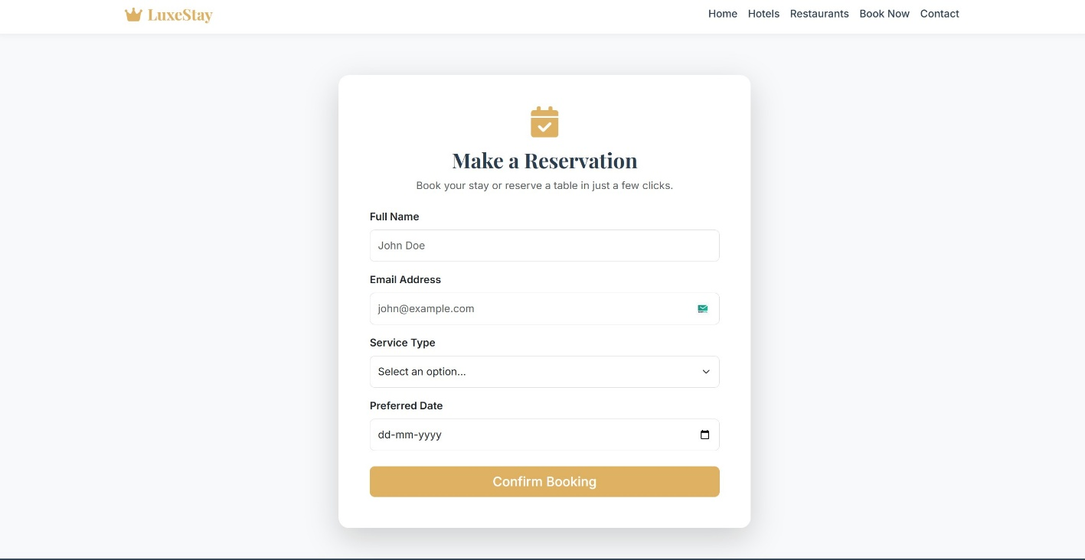

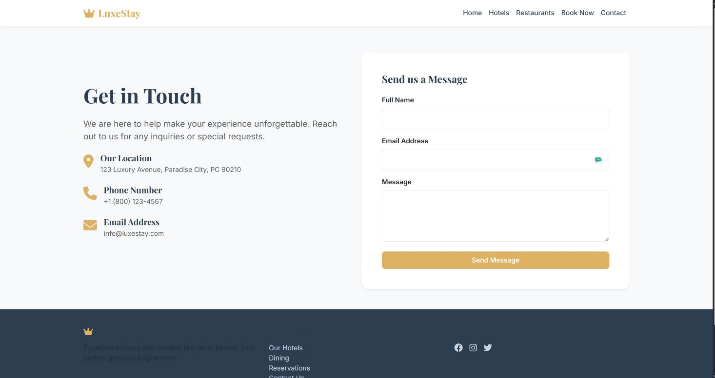

- DevOps Overview
AWS Console:
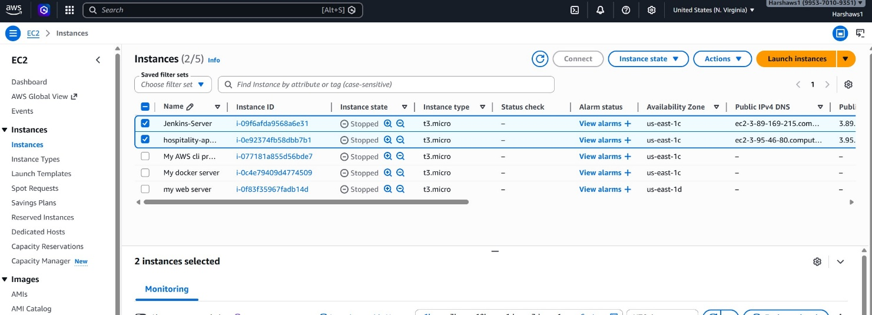

CI / CD Pipeline:

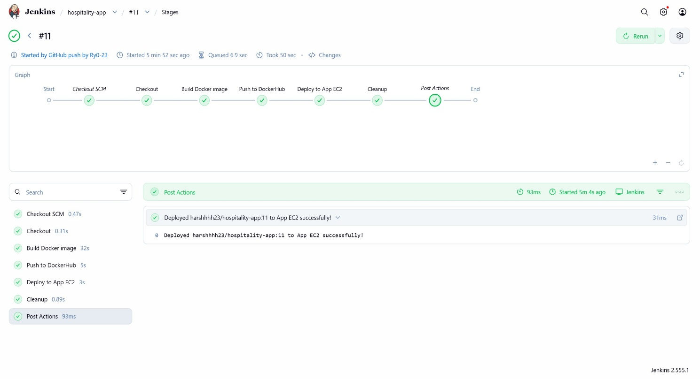

Docker Images / Containers /Builds
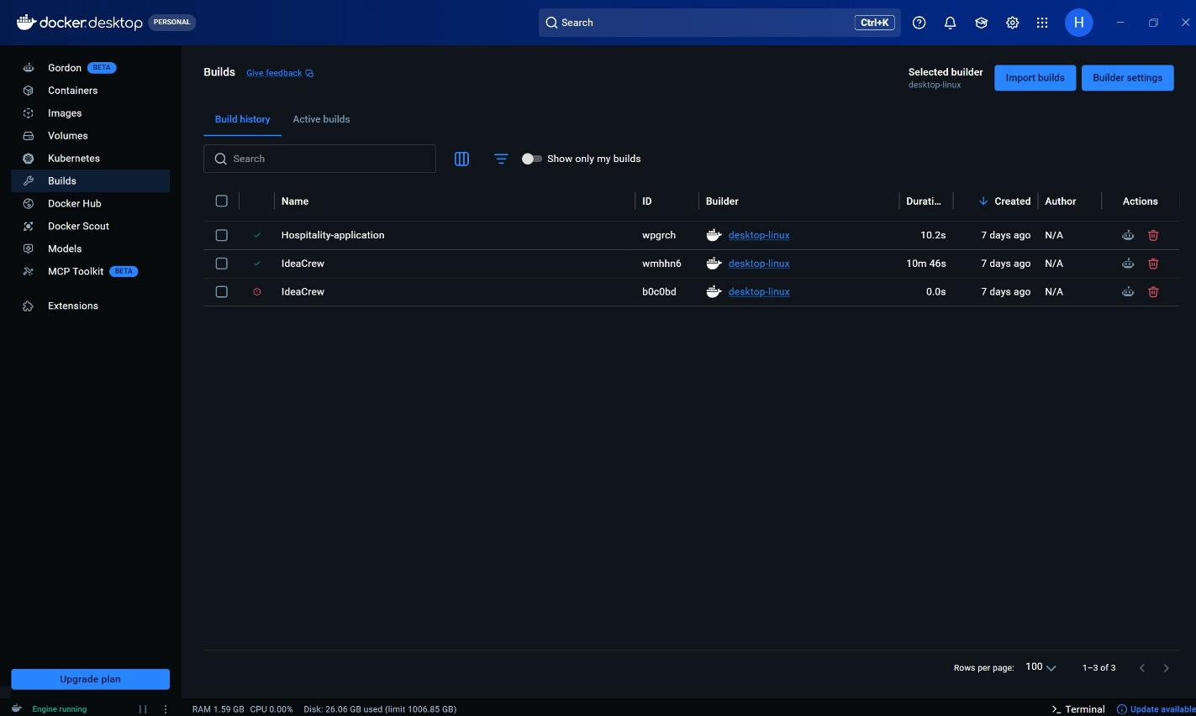

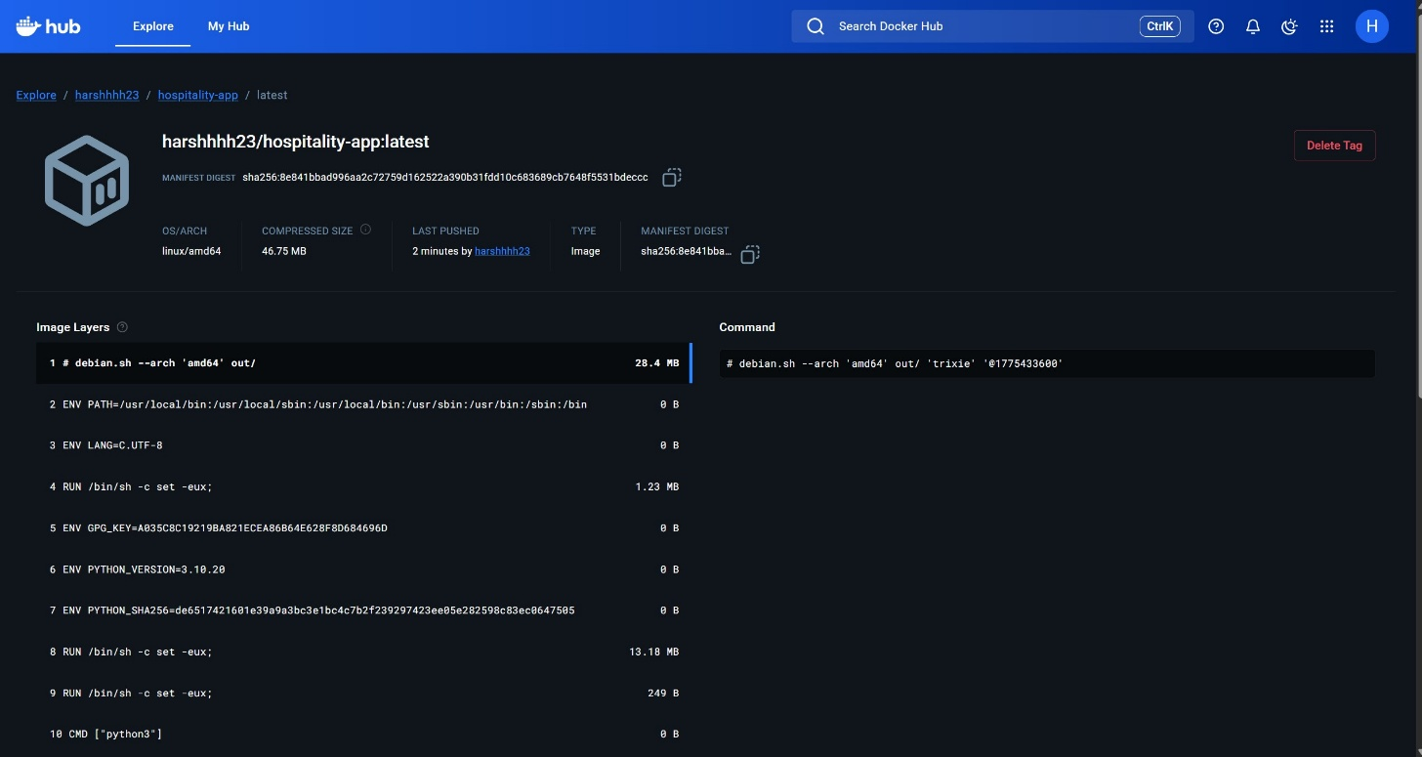

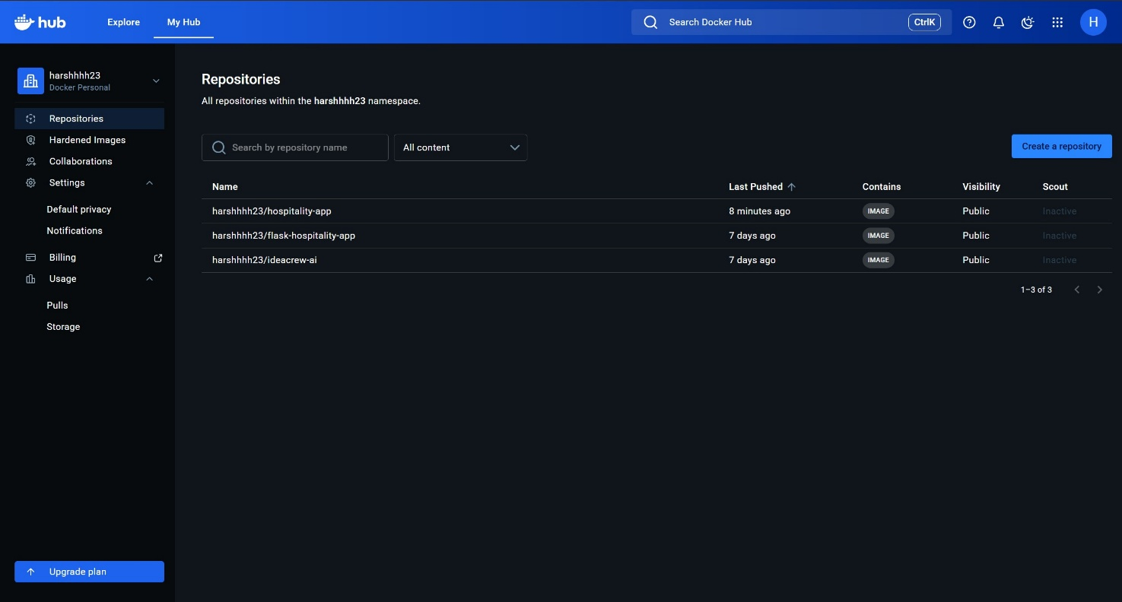

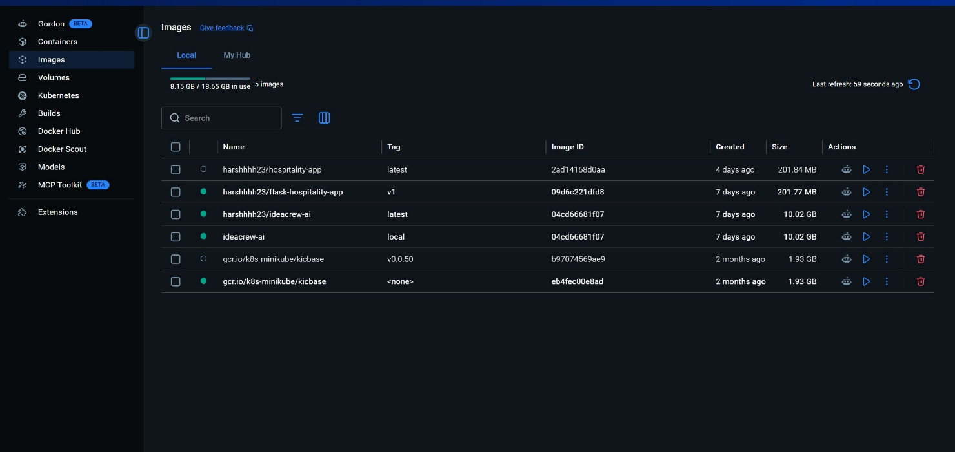

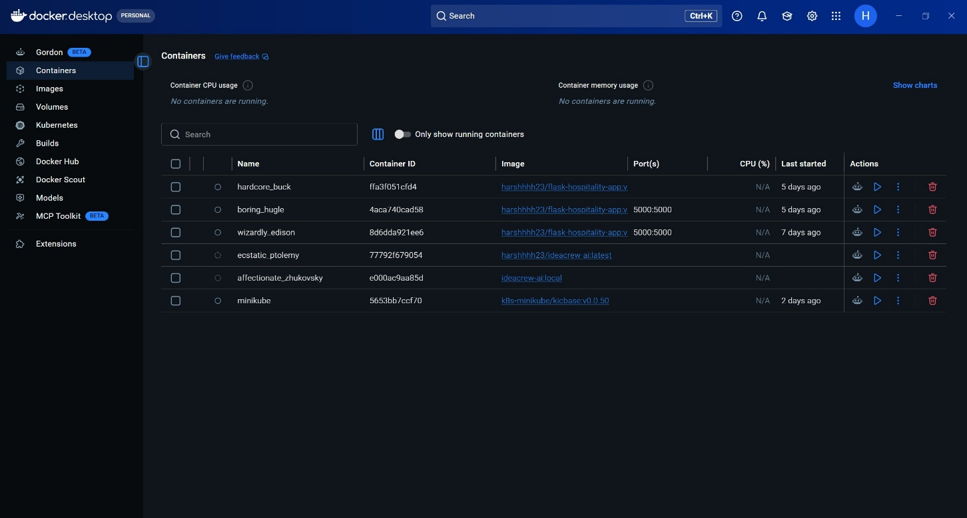

3. Key Outcomes
• Successfully developed a fully functional DevOps pipeline for automated application deployment
• Eliminated manual deployment effort through CI/CD automation using Jenkins
• Achieved consistent and reliable application deployment using Docker containerization
• Implemented Kubernetes-based orchestration for scalable and efficient application management
• Ensured zero-downtime deployments using rolling update strategy in Kubernetes
• Enabled seamless integration between GitHub, Docker Hub, and Kubernetes
• Improved deployment speed and reduced human errors through automation
• Demonstrated real-world DevOps practices including CI/CD, containerization, and orchestration

Conclusion
The Hospitality Application DevOps Pipeline successfully demonstrates the implementation of modern DevOps practices through an automated and scalable deployment system. By integrating CI/CD tools such as Jenkins, containerization using Docker, and orchestration with Kubernetes, the system ensures reliable, consistent, and efficient application delivery.
The project highlights key concepts such as continuous integration and deployment, infrastructure as code, container-based deployment, and zero-downtime updates using rolling deployment strategies. It showcases how automation can significantly reduce manual effort, minimize errors, and improve deployment speed.
The modular and extensible architecture makes the system adaptable for real-world applications, allowing easy integration of advanced features such as monitoring, auto-scaling, and cloud-based deployment. Overall, the project provides a strong foundation for implementing enterprise-level DevOps solutions

Future Scope & Enhancements
• Implement monitoring and logging using Prometheus, Grafana, and ELK Stack
• Enable auto-scaling using Kubernetes Horizontal Pod Autoscaler (HPA)
• Deploy the system on cloud platforms such as AWS (EC2/EKS) or Google Cloud (GKE)
• Use managed container registries like AWS ECR instead of Docker Hub
• Enhance CI/CD pipeline with automated testing and advanced deployment strategies
• Implement Kubernetes Ingress for domain-based routing and HTTPS support
• Improve security using Kubernetes secrets and role-based access control (RBAC)
• Extend application with database support and user authentication

